# VISVESVARAYA TECHNOLOGICAL

# UNIVERSITY

**Jnana Sangama, Belagavi-590018**



## INTERNSHIP REPORT

**‘‘PHARMACEUTICAL AGENCY & JAVA PROGRAMMING’’**

Undertaken at

**ENTREPRENEURSHIP/INNOVATION BASED INTERNSHIP**

Submitted in partial fulfilment of the requirement for the the award of the Degree

## BACHELOR OF ENGINEERING IN

**COMPUTER SCIENCE AND ENGINEERING**

### For the Academic Year 2023-2024

Submitted by

**PRATIKSHA P (3BK21CS037)**

**Under the Guidance of**

**Internal Guide External Guide**

**Prof. Suvarnalata Hiremath 1.Pradeep Kshirsagar**

**2.In28MinutesOfficial(Innovation )**



### DEPARTMENT OF COMPUTER SCIENCE AND ENGINEERING BASAVAKALYAN ENGINEERING COLLEGE BASAVAKAYLAN

**[Affiliated to VTU,Belgavi,Approved by AICTE,New Delhi]**

# BASAVAKALYAN ENGINEERING COLLEGE

**Affiliated to VTU,Belgavi,Approved by AICTE,New Delhi**

# DEPARTMENT OF COMPUTER SCIENCE AND ENGINEERING

**CERTIFICATE**



Certified that the INTERNSHIP REPORT on "PHARMACEUTICAL AGENCY" regarding the internship undertaken "FAMILY BUSINESS, BASAVAKALYAN" is prepared by at PRATIKSHA P (3BK21CS037), a bonafide student of BASAVAKALYAN ENGINEERING COLLEGE BASAVAKALYAN. The report is in partial fulfillment of the requirements for the award of the degree of Bachelor of Engineering" in Computer science and Engineering from the Visvesvaraya Technological University, Belgaum, Karnataka State, India, during the academic year 2023-2024, It is certified that all corrections/suggestions indicated for Internal Assessment have been incorporated in the report submitted to the Department. The Internship report has been approved as it satisfies the academic requirement in respect to the work prescribed for the said Degree.

**Signature of the Guide Signature of the HOD**

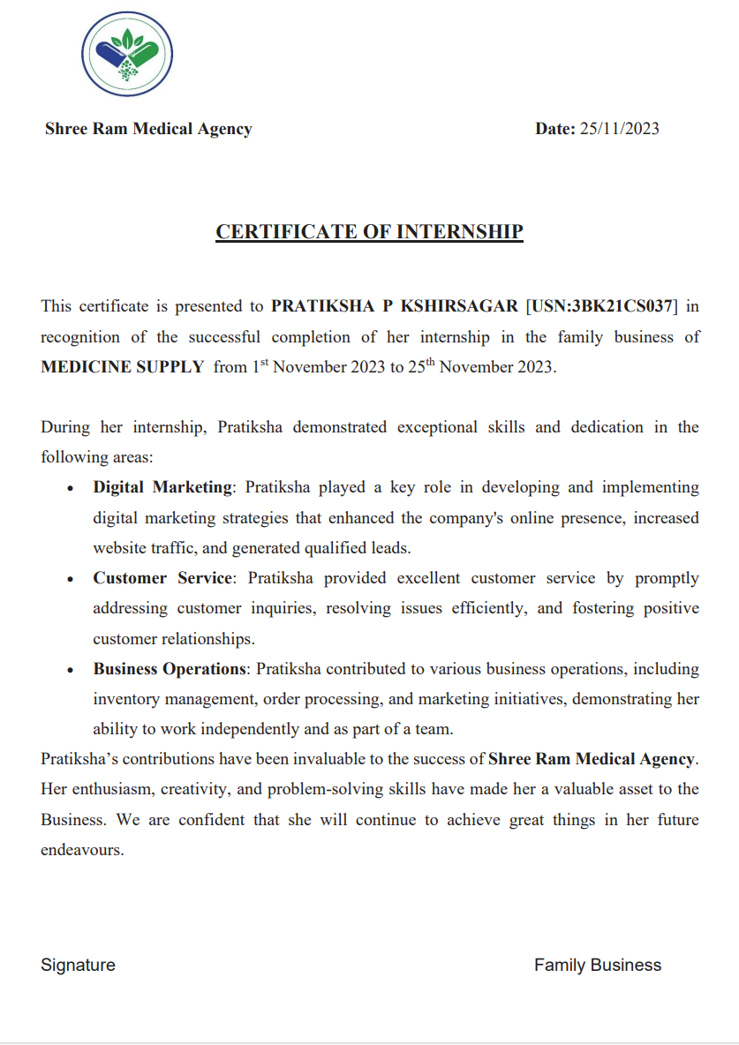

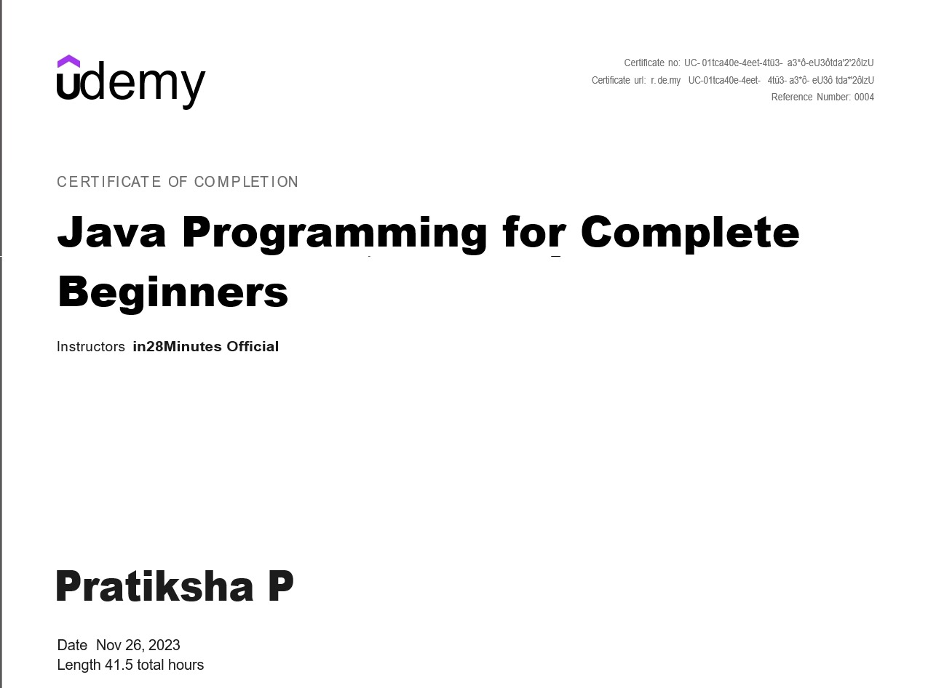

ACKNOWLEDGEMENT

I would like to express my sincere gratitude to Pradeep Kshirsagar for their invaluable guidance, mentorship, and support throughout my entrepreneurial journey. Their wisdom and expertise have been instrumental in shaping my understanding of business and fostering my growth as an entrepreneur.

Additionally, I am immensely thankful to in28Official Minutes Udemy for providing me with comprehensive knowledge and practical skills in Java Programming. The course has equipped me with the tools and insights necessary to excel in my chosen field and has greatly contributed to my professional development.

I am also grateful to Head of Department Suvarnalata Hiremath, College internship coordinator Department of CSE for their assistance and encouragement along the way.

Thank you all for your unwavering support and belief in my potential.

Sincerely,

Pratiksha P

**ABSTRACT**

This internship report delves into the transformative experiences gained from engaging with both an esteemed entrepreneur and an online course. The entrepreneur, Pradeep Kshirsagar, served as a guiding light, imparting invaluable wisdom and insights into the intricacies of entrepreneurship. Through their mentorship, I navigated the complexities of business with newfound confidence and determination.

Simultaneously, the online course, in28Official Minutes Udemy , proved to be a cornerstone in my professional development. Delving into python Java Programming, it equipped me with practical skills and theoretical knowledge essential for success in today's competitive landscape.

This abstract encapsulates the synergy between practical mentorship from a seasoned entrepreneur and structured learning from an online course, offering a holistic approach to honing entrepreneurial skills and fostering personal growth.

TABLE OF CONTENTS

|  |  |  |  |
| --- | --- | --- | --- |
| **Sl. No** | **Chapter** | **Topic** | **Page no.** |
| 1. | Chapter 1 | Introduction | 4-7 |
| 2. | Chapter 2 | Knowledge Acquired for  Entrepreneurship | 8-12 |
| 3. | Chapter 3 | Outcome of Entrepreneurship | 13-14 |
| 4. | Chapter 4 | Knowledge Acquired for  Java programming | 14-15 |
| 5. | Chapter 5 | Outcome of Java programming | 16-17 |
| 6. | Chapter 6 | Implementation of Entrepreneurship | 18-23 |
| 7. | Chapter 7 | Conclusion | 24-25 |
| 8. | References | | 26 |

**CHAPTER 1**

**INTRODUCTION TO ENTERPRENEURSHIP**

An internship in a family business can be a unique and enriching experience, blending professional development with personal insights into how businesses are run within the familial context.

1. **Understanding the Family Dynamics:** In a family business, dynamics can be complex. There may be multiple generations involved, each with their own ideas and priorities. Understanding these dynamics is crucial for navigating relationships and decision-making processes.

2. **Learning the Business:** Start by familiarizing yourself with the company's history, values, products or services, and target market. This knowledge forms the foundation for your internship experience and helps you contribute meaningfully to the business.

3. **Identifying Your Role**: Clarify your role and responsibilities with your supervisor or mentor. You might be involved in various areas such as operations, marketing, finance, or human resources. Understanding where you fit in allows you to set goals and expectations for your internship.

4. **Building Relationships:** Networking is key in any internship, but it's especially important in a family business where personal connections play a significant role. Take the time to get to know your colleagues, both family members and non-family employees, as they can offer valuable insights and support.

5. **Gaining Hands-on Experience:** One of the major benefits of an internship is gaining practical experience. Take advantage of opportunities to shadow experienced employees, work on projects, and contribute your ideas. This hands-on experience will help you develop skills and knowledge relevant to your career goals.

6. **Navigating Challenges:** Working in a family business may present unique challenges, such as balancing family dynamics with professional responsibilities or addressing conflicts of interest. Be prepared to adapt and communicate effectively to overcome these challenges.

7. **Seeking Feedback and Growth:** Actively seek feedback from your supervisors and colleagues to identify areas for improvement and opportunities for growth. Use this feedback to refine your skills and enhance your performance throughout the internship.

8. **Reflecting on Your Experience:** Take time to reflect on your internship experience, considering what you've learned, the skills you've developed, and how it aligns with your career aspirations. This reflection will help you derive maximum value from your internship and prepare for future endeavors.

Remember, an internship in a family business can be a rewarding and educational experience, offering insights into both business operations and family dynamics. Approach it with an open mind, a willingness to learn, and a commitment to professionalism.

In compiling this report for **the pharmaceutical agency**, my role as a software engineering intern has been to delve into the intricacies of technology within the organization. From my observations and analysis, it's evident that there's a significant opportunity to harness software solutions to drive efficiency and innovation across various operational facets. Through the development and refinement of tailored software applications like inventory management systems, sales tracking tools, and regulatory compliance software, I've identified tangible avenues to streamline processes and elevate overall effectiveness.

A key highlight of my findings revolves around the transformative power of **data analysis** and **visualization**. By delving into datasets encompassing **sales trends, market insights, and regulatory compliance metrics**, I've witnessed firsthand the potential for data-driven decision-making. Proposing robust data analysis tools and visualization techniques, I aim to empower stakeholders with actionable insights that propel the agency towards strategic excellence and operational efficiency.

**INTRODUCTION TO JAVA**

**What is Java?**

Java is a mature, object-oriented programming language created by Sun Microsystems (now Oracle) in 1995. It's designed with a balance of power and ease of use, making it a general-purpose language suitable for building a wide variety of applications. Here are some key aspects of Java:

* **Object-oriented:** Java adheres to object-oriented programming (OOP) concepts. In OOP, code is organized around reusable objects that represent real-world entities. An object encapsulates data (its attributes) and the code that manipulates that data (its methods). This modular approach fosters code reusability, maintainability, and promotes better program design.
* **Platform-independent:** Java is famous for its "write once, run anywhere" (WORA) capability. Java code is compiled into bytecode, an intermediate format that can be executed on any platform with a Java Runtime Environment (JRE). The JRE interprets the bytecode and translates it into instructions specific to the underlying hardware. This eliminates the need to rewrite code for different operating systems.
* **Secure:** Java incorporates robust security features to make it less vulnerable to security breaches and errors. It enforces strict memory management, preventing memory leaks and crashes that can plague other languages. Additionally, Java restricts direct access to memory addresses, making it more resistant to malware.
* **General-purpose:** Java's versatility allows it to be used in various domains, such as:
  + **Web development:** Java plays a significant role in web development, particularly on the back-end side. Java servlets and frameworks like Spring handle server-side logic and database interactions for web applications.
  + **Mobile app development:** While not the only option, Java is a cornerstone technology behind Android app development. The Android operating system itself is written in Java, and many popular Android development tools leverage Java.
  + **Desktop applications:** Java can be used to create feature-rich desktop applications with graphical user interfaces (GUIs).
  + **Big data:** The Hadoop ecosystem, a popular framework for processing large datasets, heavily relies on Java.

**Why Use Java?**

Java's enduring popularity stems from several factors:

* **High demand:** Java consistently ranks among the most in-demand programming languages in the job market. Having Java skills on your resume can open doors to various programming opportunities.
* **Large and supportive community:** With a vast global community of Java developers, you'll find a wealth of online resources, tutorials, and forums for learning, troubleshooting, and staying up-to-date with the latest advancements.
* **Relatively easy to learn:** Java's syntax bears a resemblance to C and C++, making it easier for programmers familiar with those languages to pick up. The focus on object-oriented concepts promotes well-structured and readable code

**CHAPTER 2**

**KNOWLEDGE ACQUIRED FOR ENTERPRENEURSHIP**

**Introduction:**

The onset of our journey towards digital transformation within the pharmaceutical agency marked a pivotal moment in our quest for operational excellence. As a software engineering intern, I undertook the responsibility of comprehensively understanding the agency's operational intricacies, particularly its reliance on manual record-keeping practices. This initial phase was characterized by an immersive exploration into the depths of our legacy system, wherein I uncovered a tapestry of challenges that impeded efficiency and hindered our ability to adapt to the demands of a rapidly evolving industry landscape. From the labyrinthine maze of paperwork to the laborious processes of data retrieval and compliance management, the shortcomings of our manual record-keeping system became glaringly apparent. However, beneath these challenges lay the seeds of opportunity – an opportunity to reimagine our operational framework through the lens of digital innovation and technological advancement.

**Understanding the Legacy System:**

The journey towards digital transformation commenced with a meticulous examination of our legacy record-keeping practices. Through a series of in-depth interviews, process mapping exercises, and data audits, I gained invaluable insights into the inner workings of our manual system. What emerged from this exploration was a comprehensive understanding of the multifaceted challenges that plagued our operations – from the inefficiencies of paper-based documentation to the complexities of compliance management in an increasingly regulated environment. It became abundantly clear that the status quo was no longer tenable, and that transformative action was imperative if we were to thrive in the face of mounting operational pressures. Armed with this newfound clarity, I set forth on a mission to chart a course towards digital transformation, guided by the twin pillars of innovation and strategic foresight.

**Proposal for Digital Transformation:**

With a deep understanding of our legacy system's limitations, I embarked on crafting a comprehensive proposal for digital transformation. This proposal served as a blueprint for our journey towards modernization, outlining the strategic imperatives and technological solutions necessary to propel our operations into the digital age. Rooted in a thorough analysis of our current state and informed by industry best practices, the proposal articulated a compelling vision for the future – one characterized by streamlined processes, enhanced data integrity, and heightened agility in response to market dynamics. Central to this vision was the adoption of cutting-edge software solutions tailored to our unique needs, including inventory management systems, sales tracking tools, and regulatory compliance software. Moreover, the proposal underscored the transformative potential of digital innovation, highlighting its role in driving cost savings, productivity gains, and competitive differentiation in an increasingly digital landscape. As I presented the proposal to key stakeholders, I articulated the strategic imperative of embracing digital transformation as a catalyst for organizational growth and resilience in a rapidly evolving industry.

**Contributions to Digital Implementation:**

With the green light for digital transformation secured, I transitioned from planning to action, spearheading the design, development, and deployment of our suite of software applications. Drawing upon my expertise in software engineering, I collaborated closely with cross-functional teams to translate conceptual visions into tangible solutions that addressed our most pressing operational challenges. This phase of the journey was characterized by a relentless pursuit of excellence, as we iterated upon prototypes, conducted rigorous testing, and incorporated user feedback to refine our solutions iteratively. From optimizing inventory management processes to streamlining sales tracking workflows, each application was meticulously crafted to deliver measurable value and drive operational efficiency. Moreover, I championed a culture of innovation and collaboration throughout the implementation process, fostering a sense of ownership and buy-in among team members at every level of the organization. As our digital solutions began to take shape, I witnessed firsthand the transformative power of technology to reshape our operational landscape and position us for success in the digital age.

**Overcoming Challenges and Driving Adoption:**

The journey towards digital transformation was not without its fair share of challenges. From overcoming resistance to change to navigating technical complexities, I encountered numerous obstacles along the way. However, armed with a clear vision and unwavering determination, I forged ahead, leveraging effective communication, stakeholder engagement, and targeted training initiatives to overcome these challenges and drive widespread adoption of our digital solutions. Recognizing the importance of organizational buy-in, I worked closely with leadership to articulate the strategic imperative of digital transformation and the tangible benefits it promised for our agency. Through transparent communication and ongoing dialogue, I sought to alleviate concerns, address misconceptions, and foster a culture of innovation and collaboration. Moreover, I spearheaded targeted training programs to equip team members with the skills and knowledge necessary to embrace and leverage our new digital tools effectively. By showcasing the tangible benefits of digital transformation – from time savings and error reduction to enhanced data security and compliance – I galvanized support and enthusiasm for the initiative across all levels of the organization, paving the way for a smooth transition and a brighter future for our agency.

**Impact and Future Directions:**

As the dust settled on our digital transformation journey, the impact of our efforts became increasingly apparent. With streamlined workflows, enhanced data-driven insights, and fortified compliance measures, our agency emerged stronger and more resilient than ever before. The transformative power of technology had unlocked new possibilities and positioned us for sustained success in an increasingly digital landscape. Looking ahead, I remain committed to the pursuit of excellence, advocating for continuous optimization and innovation to maintain our competitive edge and drive ongoing growth and innovation. By leveraging emerging technologies such as artificial intelligence and blockchain, I believe we can unlock new frontiers of operational efficiency and effectiveness, further solidifying our position as a leader in the pharmaceutical industry. As we chart a course towards the future, I am confident that our commitment to digital transformation will continue to serve as a catalyst for innovation, growth, and success in the years to come.

**Some additional ideas to boost the pharmaceutical agency's business:**

**1. Portfolio Website Development**: Create a comprehensive online portfolio showcasing the agency's products, services, and achievements. This website can serve as a valuable marketing tool, providing potential clients with easy access to information about the agency's offerings and expertise. It can also include case studies, client testimonials, and success stories to highlight the agency's track record of delivering results.

**2. E-commerce Platform Integration:** Explore the possibility of integrating an e-commerce platform into the agency's website, allowing customers to place orders for pharmaceutical products online. This can streamline the ordering process, improve customer convenience, and expand the agency's reach to a wider audience.

**3. Mobile App Development:** Develop a mobile app that provides valuable resources and tools for healthcare professionals, such as drug information databases, dosage calculators, and medical news updates. This app can serve as a valuable resource for healthcare professionals, enhancing their productivity and efficiency.

**4. Telemedicine Services:** Consider offering telemedicine services that allow patients to consult with healthcare providers remotely. This can include virtual appointments, online prescription refills, and remote monitoring tools for managing chronic conditions. By embracing telemedicine, the agency can expand its service offerings and reach patients who may have limited access to traditional healthcare services.

**5. Supply Chain Optimization**: Implement advanced supply chain management solutions to optimize inventory levels, reduce costs, and improve efficiency. This can include the use of predictive analytics to forecast demand, real-time tracking of shipments, and automated replenishment processes to ensure timely delivery of pharmaceutical products.

**6. Clinical Research Collaboration:** Forge partnerships with research institutions and pharmaceutical companies to collaborate on clinical research studies and drug development projects. By participating in clinical research, the agency can contribute to scientific advancements, gain access to cutting-edge treatments, and enhance its reputation as a leader in the field.

**7. Community Outreach Initiatives:** Engage in community outreach initiatives to raise awareness about important health issues and promote preventive care. This can include health fairs, educational seminars, and partnerships with local organizations to support underserved populations. By actively participating in the community, the agency can demonstrate its commitment to improving public health and building trust with patients and healthcare providers.

**CHAPTER 3**

**OUTCOME**

After introducing the online recording system and transitioning from manual paperwork, several significant outcomes were observed within the pharmaceutical agency:

**1. Improved Efficiency:** The most notable outcome was a marked improvement in operational efficiency. Tasks that once required extensive manual effort, such as data entry, record-keeping, and information retrieval, were streamlined through the use of digital tools. This resulted in time savings and increased productivity among staff members, allowing them to focus their efforts on more value-added activities.

**2. Enhanced Accuracy and Data Integrity:** The online recording system contributed to enhanced accuracy and data integrity compared to the previous manual paper-based processes. Digital records were less prone to errors such as illegible handwriting, misplaced documents, or data duplication. This improved accuracy not only increased confidence in the reliability of the data but also facilitated better decision-making based on accurate and up-to-date information.

**3. Enhanced Regulatory Compliance:** The digital recording system enhanced regulatory compliance by providing a centralized repository for storing and managing compliance-related documents and records. This facilitated easier tracking of regulatory requirements, expiration dates, and audit trails, ensuring that the agency remained compliant with industry regulations and standards. Moreover, automated alerts and notifications helped ensure timely renewals and adherence to compliance deadlines.

**4. Cost Savings:** Transitioning from manual paperwork to digital recording resulted in cost savings for the pharmaceutical agency. By reducing the need for paper, printing, and storage space, the agency saved on material costs and operational expenses associated with managing physical records. Additionally, increased efficiency and productivity translated into labor cost savings as staff members were able to accomplish more in less time.

**CHAPTER 4**

**KNOWLEDGE ACQUIRED FOR JAVA**

Here are some of the key things you can learn during an internship related to Java programming:

**Technical Skills:**

* **Practical application of Java concepts:** You'll gain hands-on experience applying the Java knowledge you learned in school or through self-study to real-world projects. This could involve tasks like writing code modules, debugging existing code, or contributing to specific features of a Java application.
* **Exposure to Java frameworks and libraries:** Many companies leverage Java frameworks and libraries to streamline development. During your internship, you might have the opportunity to work with popular frameworks like Spring for web development or JavaFX for building desktop applications with graphical interfaces.
* **Version control systems (VCS) like Git:** In a collaborative development environment, using Git for version control becomes essential. An internship can provide practical experience with Git for tracking changes, collaborating with teammates, and managing different code versions.
* **Testing methodologies:** Writing unit tests and integrating with automated testing frameworks is an important aspect of professional software development. Your internship might involve writing unit tests for your code or working with existing test suites to ensure code quality.

**Soft Skills:**

* **Professional communication:** Internships provide opportunities to hone your communication skills in a professional setting. This could involve communicating technical concepts to colleagues, writing clear and concise documentation, or participating in code reviews.
* **Problem-solving and critical thinking:** In the workplace, you'll encounter problems that require creative solutions and analytical thinking. Your internship will likely present challenges that will test your problem-solving abilities and how you approach debugging and resolving technical issues.
* **Teamwork and collaboration:** Software development is rarely a solitary endeavor. Internships allow you to develop your teamwork skills by collaborating with other developers, designers, and testers to achieve a common goal. You'll learn to work effectively within a team, delegate tasks, and value different perspectives.
* **Work ethic and professionalism:** Internships are a chance to demonstrate your work ethic, time management skills, and ability to meet deadlines. You'll learn the importance of professionalism in the workplace, including proper etiquette, communication, and maintaining a positive attitude.

**Additionally:**

* **Industry-specific practices:** Depending on the company you intern for, you might gain exposure to industry-specific development practices, coding standards, and tools used in that particular domain.
* **Networking opportunities:** Internships can open doors to professional connections within the company or the industry. Network with colleagues, mentors, and supervisors to build relationships that could be valuable in your future career.

By leveraging the learning opportunities an internship offers, you can gain valuable technical and soft skills that will make you a more well-rounded and competitive programmer upon entering the workforce.

**CHAPTER 5**

**OUTCOME OF JAVA**

**Outcomes :**

**Enhanced Skills**: You've likely gained practical experience and improved your Java programming skills, including understanding object-oriented programming, data structures, algorithms, and possibly frameworks or libraries specific to Java.

**Portfolio Development**: You may have added projects or contributions to your portfolio, showcasing your work to potential employers.

**Professional Network**: Internships often provide opportunities to network with professionals in the industry, which can be beneficial for future job opportunities.

**Career Clarity**: This experience can help clarify your career interests, whether you want to continue in Java development, explore other areas of software engineering, or even shift to a different tech role

**Impact :**

**Employability**: Practical experience from an internship makes you a more attractive candidate to employers. It demonstrates that you have real-world experience and can apply your knowledge in a professional setting.

**Confidence**: Successfully completing an internship can boost your confidence in your technical abilities and problem-solving skills.

**Industry Insight**: Internships often provide insights into industry standards, best practices, and the latest technologies, keeping you updated with current trends.

**Professional Growth**: The mentorship and feedback received during an internship can significantly contribute to your professional and personal growth

**Career Impact :**

**Resume Enhancement:** Adding significant experience to your resume, making you more competitive in the job market.

**Job Opportunities:** Increasing your chances of receiving job offers, either from the company where you interned or from other potential employers who value practical experience.

**Career Path Exploration:** Gaining insights into different career paths within software development and helping you make informed decisions about your future career.

**Personal Growth :**

**Time Management:** Learning to manage your time effectively, balancing multiple tasks and deadlines.

**Adaptability**: Developing the ability to adapt to new technologies, tools, and working environments.

**Confidence and Independence**: Building confidence in your abilities and becoming more independent in your work.

**CHAPTER 6**

**IMPLEMENTATIONS OF ENTERPRENEURSHIP**

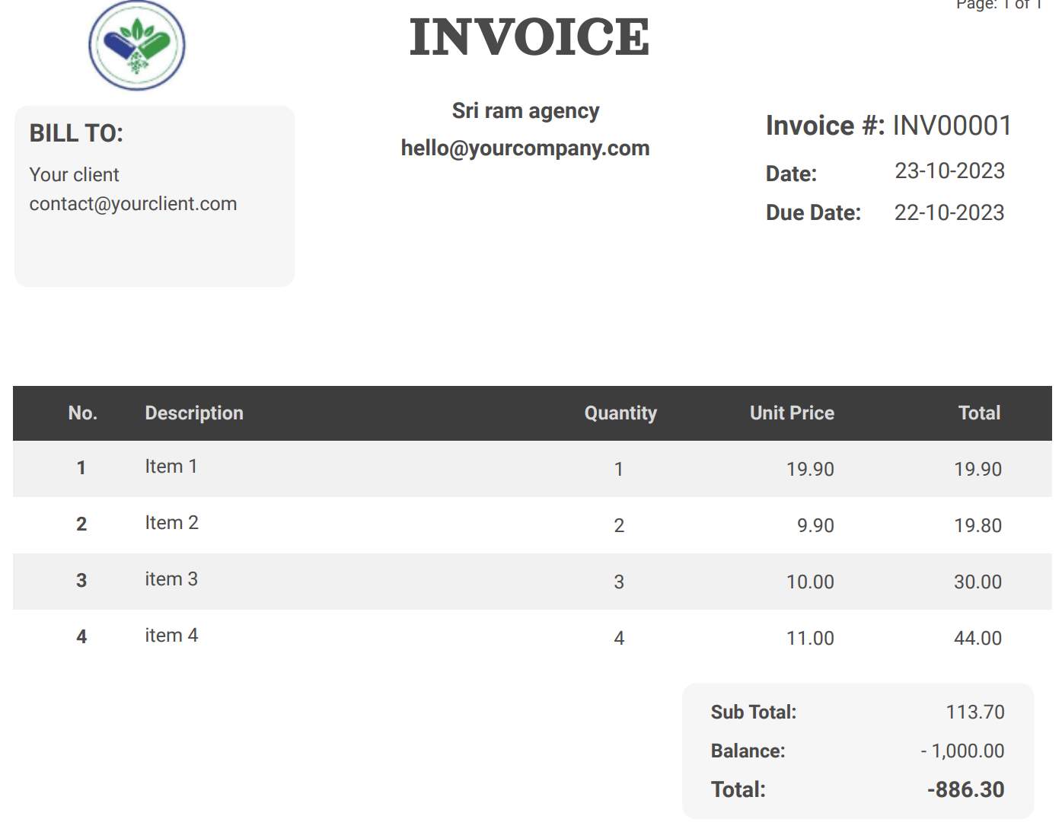



**BEFORE MANUAL WORK**

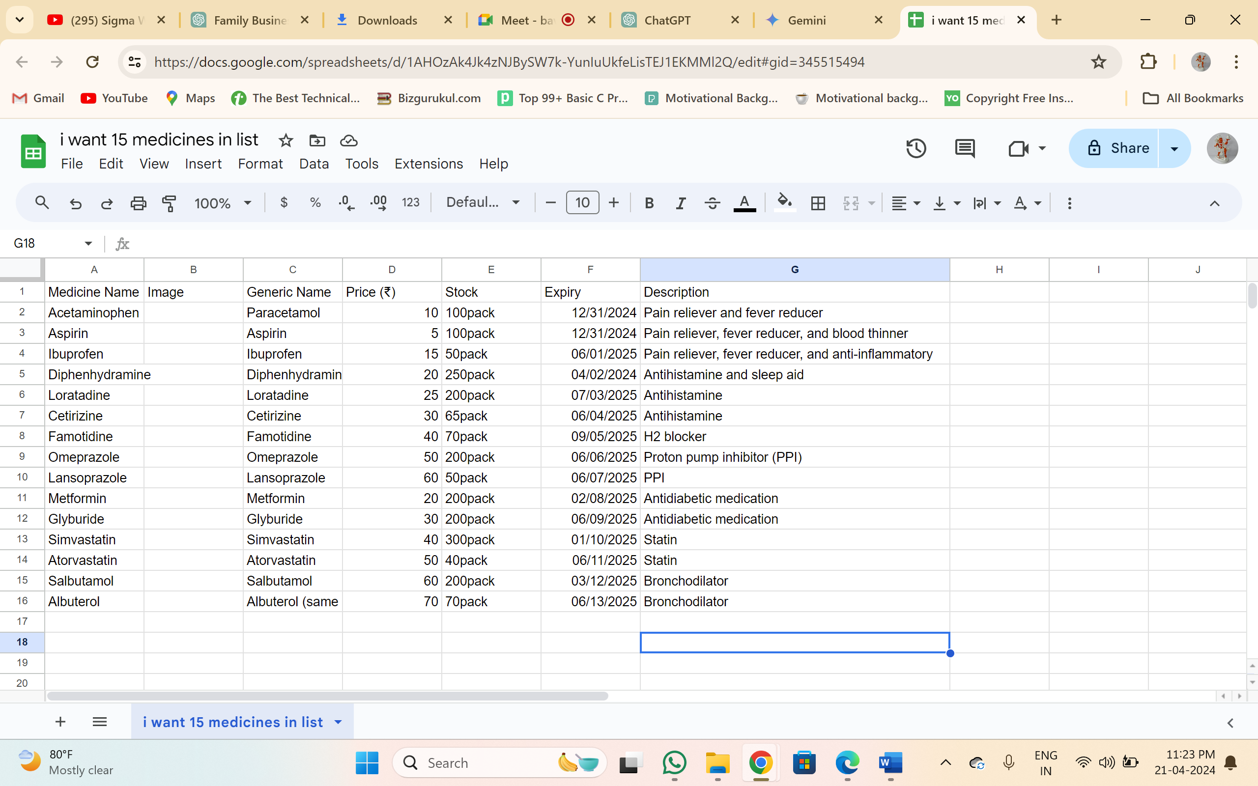 **AFTER USING EXCEL SHEET**

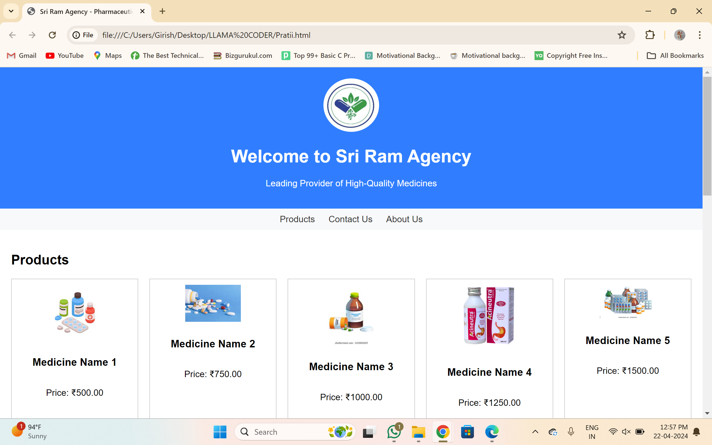

**PORTFOLIO WEBSITE**

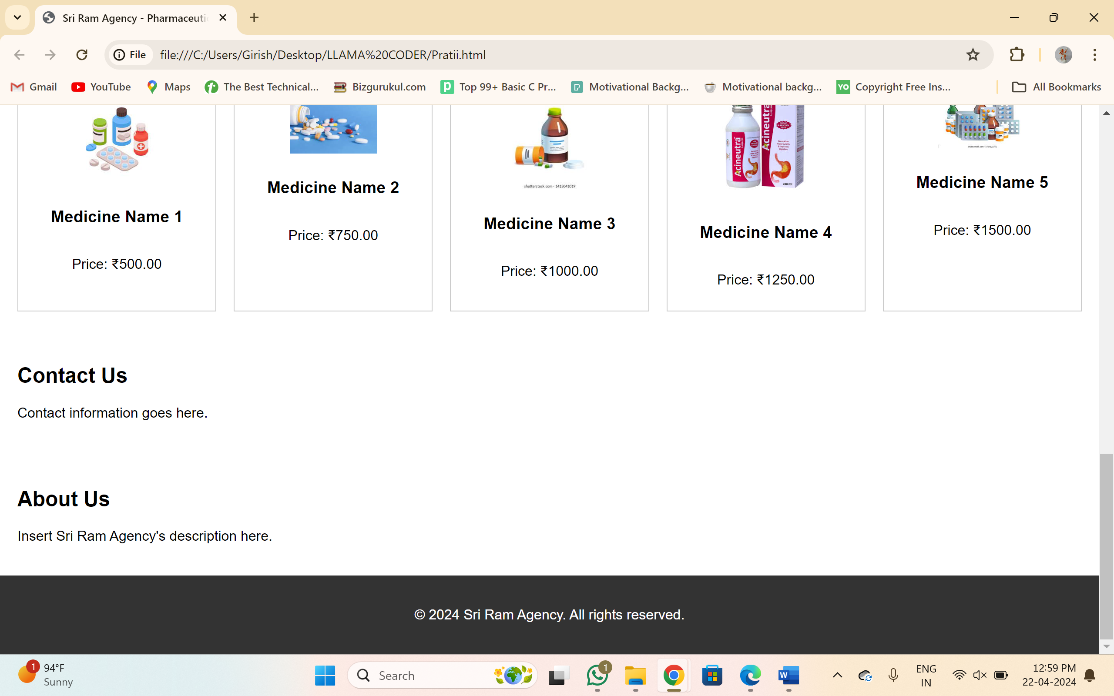







**AGENCY WAREHOUSE**

**AGENCY WAREHOUSE**

**CHAPTER 7**

**CONCLUSION**

**Entrepreneurship Internship :**

In conclusion, the internship journey within the pharmaceutical agency has been a transformative experience marked by significant achievements and valuable insights. Through the introduction of the online recording system and the transition from manual paperwork to digital processes, several key outcomes have been observed, ranging from improved efficiency and accuracy to enhanced regulatory compliance and customer service. The adoption of digital tools and processes has not only streamlined operations and increased productivity but has also positioned the agency for continued success and growth in an increasingly digital-driven industry landscape.

Throughout the internship, the importance of leveraging technology for operational excellence has been underscored, highlighting the transformative power of innovation and strategic foresight. From conceptualizing and implementing digital solutions to overcoming challenges and driving adoption, the internship has been a testament to the value of collaboration, perseverance, and adaptability in navigating complex organizational landscapes.

Looking ahead, the lessons learned and experiences gained during the internship will serve as a solid foundation for future endeavors in the field of software engineering and technology. As the pharmaceutical agency continues on its journey of digital transformation, I remain committed to embracing innovation, driving continuous improvement, and contributing to the advancement of operational excellence within the organization. With a newfound appreciation for the impact of technology on business operations and a passion for driving positive change, I am excited to apply the knowledge and skills acquired during the internship to future opportunities and challenges in the dynamic world of software engineering.

**Java Programming** :

In conclusion, this Java programming internship proved to be an invaluable experience that not only strengthened my foundational knowledge of Java but also provided me with practical hands-on experience in applying those concepts to real-world projects. Throughout the internship, I had the opportunity to delve into object-oriented programming principles, data structures and algorithms, unit testing frameworks. This not only solidified my understanding of these core Java principles but also fostered my ability to apply them in a collaborative environment.

Overall, this internship has significantly enhanced my confidence as a Java programmer and fueled my passion for pursuing a career in this field. I am eager to leverage the skills and knowledge I gained here to tackle new challenges and contribute meaningfully to future projects.

**REFERENCES**

[**https://www.w3schools.com/java/**](https://www.w3schools.com/java/)

[**https://chatgpt.com/?oai-dm=1**](https://chatgpt.com/?oai-dm=1)

[**https://gemini.google.com/app**](https://gemini.google.com/app)

[**https://www.uIREdemy.com/**](https://www.udemy.com/)